Completing the Bright from the Start Roster in Infinite Campus
Step-by-Step Instructions

Step 1: Go to https://ic.apsk12.org and sign into Infinite Campus using your username and password.
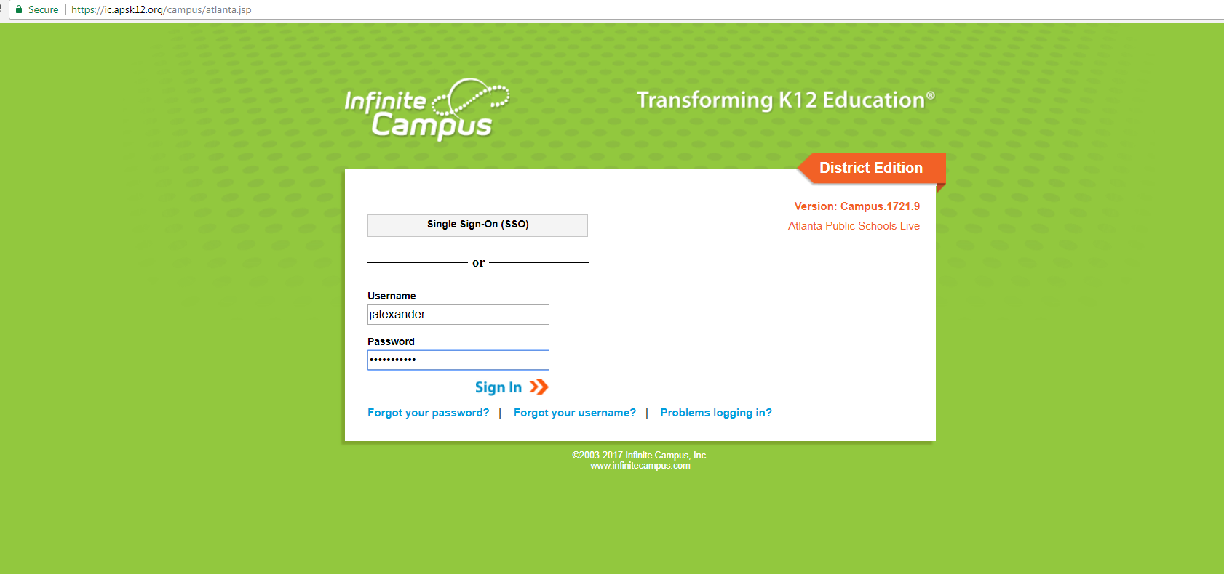

Step 2: Now that you are logged in, click “Roster” on the left side of the screen. Once you click “roster”, your class list will appear.
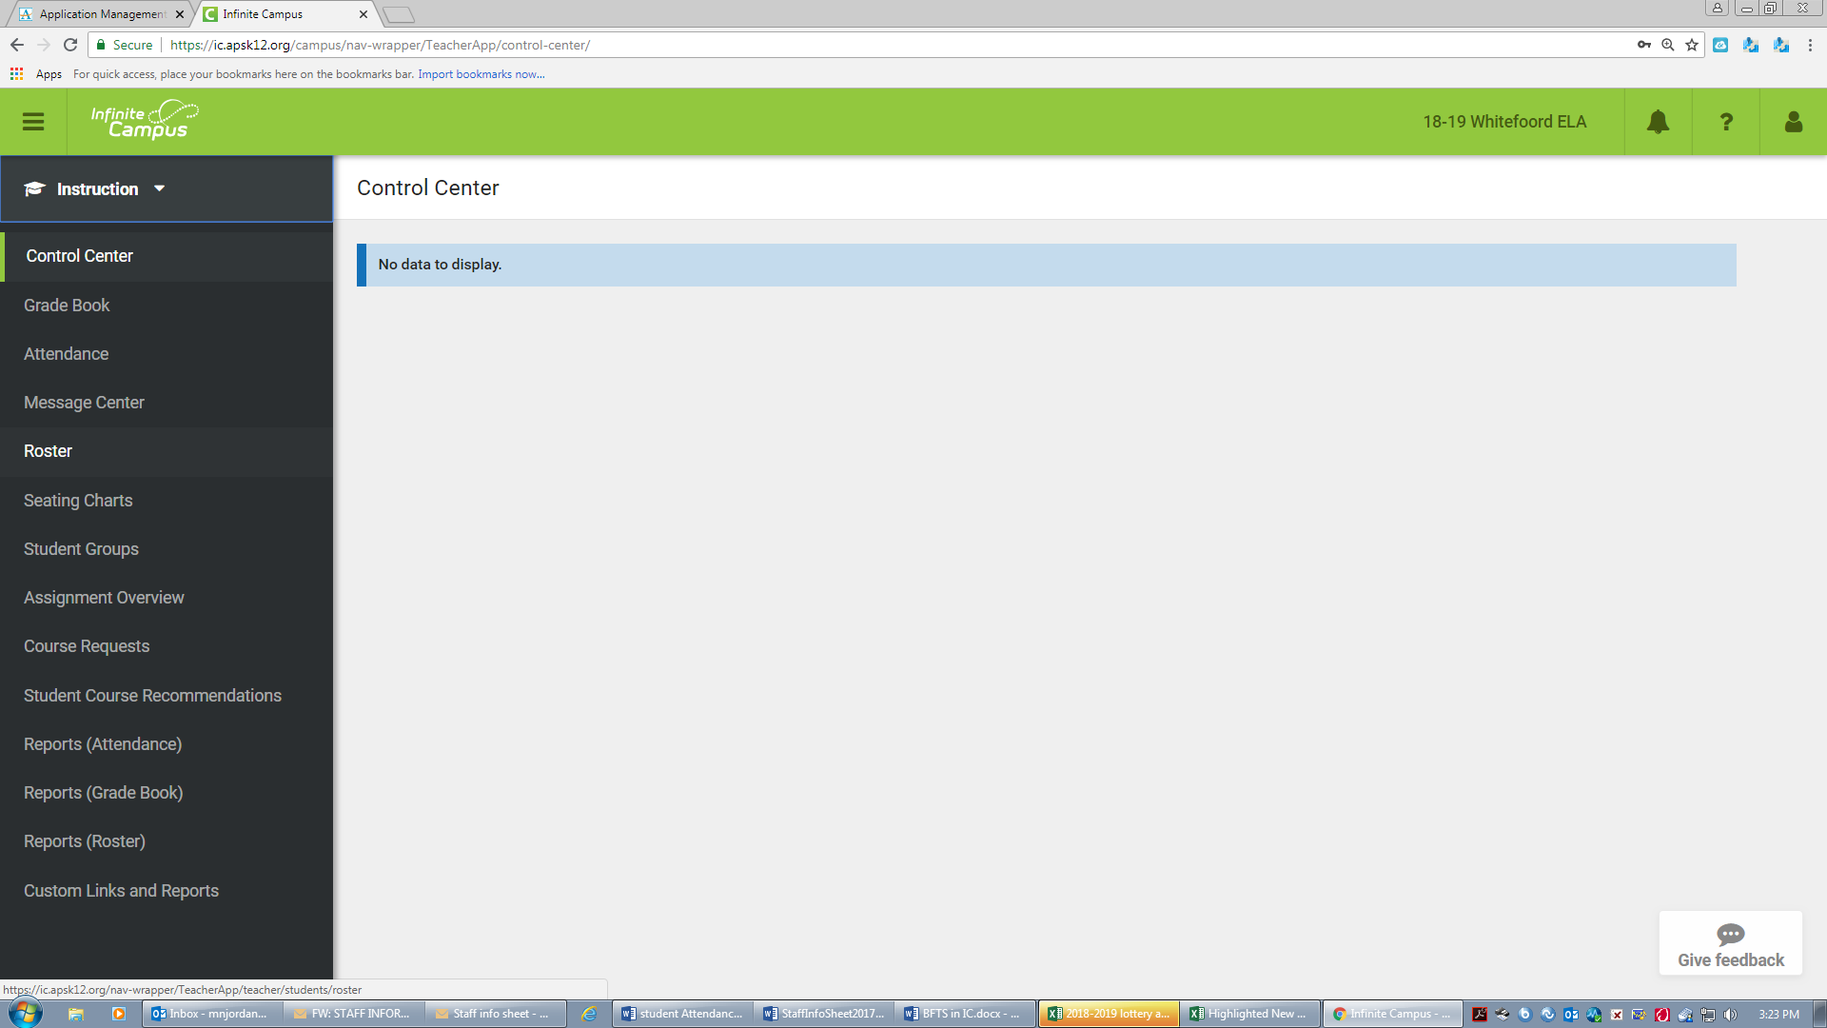
Click Roster here
Step 3: Click the student’s name. After you click the student’s name, a box will appear. Click “To student information” within the box.
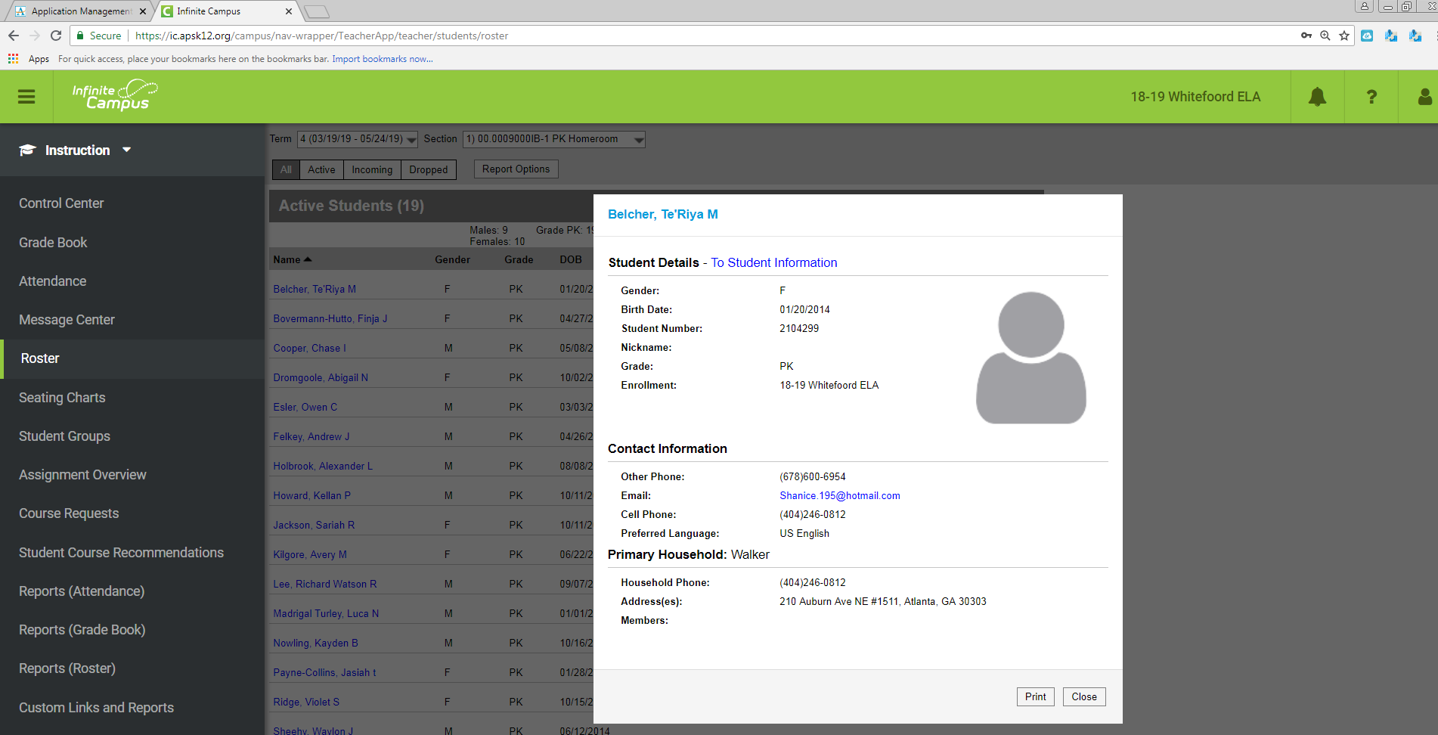
Click here

Step 4: Click “BFTS tab” at the top of the screen.
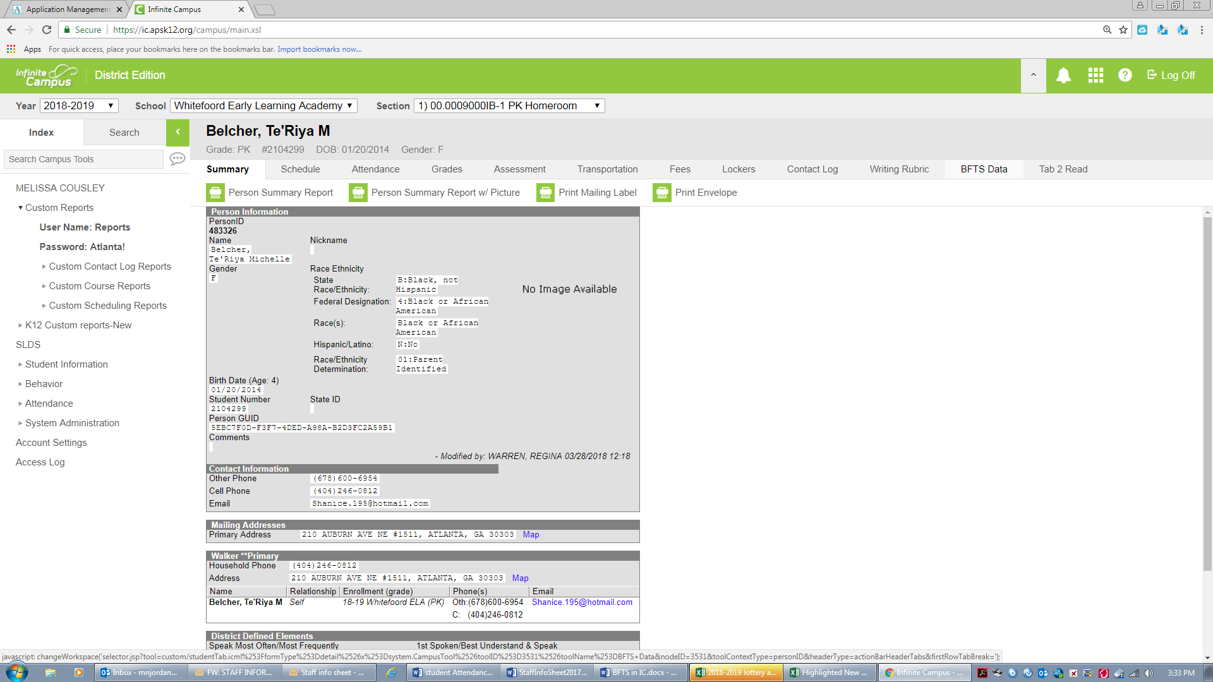
BFTS Tab

Step 5: Enter the students Birth Indicator, Transportation, Socio/Economic and Funding. You will only enter a waiver reason code if the student does not have a social security card in their file. Students without a social security card, will have a social security waiver in their file. See sample SSN Waiver below. If a waiver is present, enter the corresponding code. For parents who selected waiver reason #5, enter the reason that the parent decided not to provide the students SSN where is says waiver reason detail. Waiver reason detail should ONLY be completed if the parent selected code 5. If the parent selected code 1-4, enter the code and leave waiver reason detail blank. Click save when done and search for your next student.

Waiver Reason Code

Sample Social Security Waiver

Waiver Reason Code 1-5

FAQ’s
- If my student has a social security card in their file, do I enter a waiver reason code/detail?
  - No. You will enter all other required info, leaving waiver reason code/detail blank and click save.
- How do I determine if a student is considered category 1 or 2 under Socio/Economic Status?
  - Look into the student’s blue folder. If the student’s family receives any benefits from the state such as food stamps, Medicaid, TANF, CAPS, the student is considered to be category 1. Note: Proof that a student is category 1 must be in the folder, having a card or a letter from the Department of Family and Children Services present. All students that do not receive these benefits are category 2.
- When must I have my roster complete?
  - Your roster is due five times a year on:
    - August 20, 2018 (For WSO)
    - September 7, 2018
    - November 2, 2018
    - January 11, 2019
    - March 15, 2019
  - For the 1st initial roster, you must complete these steps for every student in your class and for every student that has withdrawn from your class. On the last three rosters, you are basically making updates completing these steps for new students that enrolled after your last roster submission.
- What do I do if I have a student in my class who is not in infinite campus?
  - Contact your school secretary immediately.
- Do I select “lottery” or “blended” for funding?
  - If you work at a non-Head Start site, you will select “lottery” for every student. If you work at a Head Start site, you will select “blended” for every student.
- Who can I call if I have questions?
  - Contact Monica Smith at 404-802-3638.

